What is Data Mining?
Data mining is the process of extracting useful information or knowledge from large amounts of data using various statistical and computational techniques. The data can be structured, semi-structured or unstructured, and can be stored in various forms such as databases, data warehouses, and data lakes.
The primary goal of data mining is to discover hidden patterns and relationships in the data that can be used to make informed decisions or predictions. This involves exploring the data using various techniques such as clustering, classification, regression analysis, association rule mining, and anomaly detection.

Data Mining Process
The data mining process typically involves the following steps:
Business Understanding: This step involves understanding the problem that needs to be solved and defining the objectives of the data mining project. This includes identifying the business problem, understanding the goals and objectives of the project, and defining the KPIs that will be used to measure success. This step is important because it helps ensure that the data mining project is aligned with business goals and objectives.
Data Understanding: This step involves collecting and exploring the data to gain a better understanding of its structure, quality, and content. This includes understanding the sources of the data, identifying any data quality issues, and exploring the data to identify patterns and relationships. This step is important because it helps ensure that the data is suitable for analysis.
Data Preparation: This step involves preparing the data for analysis. This includes cleaning the data to remove any errors or inconsistencies, transforming the data to make it suitable for analysis, and integrating the data from different sources to create a single dataset. This step is important because it ensures that the data is in a format that can be used for modeling.
Modeling: This step involves building a predictive model using machine learning algorithms. This includes selecting an appropriate algorithm, training the model on the data, and evaluating its performance. This step is important because it is the heart of the data mining process and involves developing a model that can accurately predict outcomes on new data.
Evaluation: This step involves evaluating the performance of the model. This includes using statistical measures to assess how well the model is able to predict outcomes on new data. This step is important because it helps ensure that the model is accurate and can be used in the real world.
Deployment: This step involves deploying the model into the production environment. This includes integrating the model into existing systems and processes to make predictions in real time. This step is important because it allows the model to be used in a practical setting and to generate value for the organization.

Data Preprocessing in Data Mining

Data preprocessing is an important step in the data mining process. It refers to the cleaning, transforming, and integrating of data in order to make it ready for analysis. The goal of data preprocessing is to improve the quality of the data and to make it more suitable for the specific data mining task.
Steps Involved in Data Preprocessing

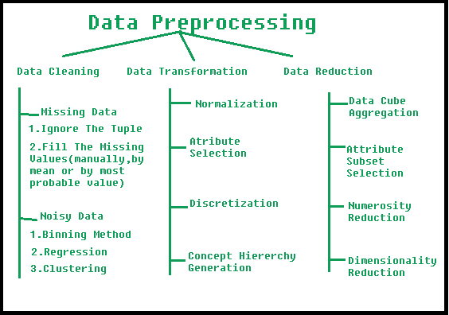

1. Data Cleaning:
The data can have many irrelevant and missing parts. To handle this part, data cleaning is done. It involves handling of missing data, noisy data etc.
- (a). Missing Data:
This situation arises when some data is missing in the data. It can be handled in various ways.
Some of them are:
  - Ignore the tuples:
This approach is suitable only when the dataset we have is quite large and multiple values are missing within a tuple.
  - Fill the Missing values:
There are various ways to do this task. You can choose to fill the missing values manually, by attribute mean or the most probable value.
- (b). Noisy Data:
Noisy data is meaningless data that can’t be interpreted by machines. It can be generated due to faulty data collection, data entry errors, etc. It can be handled in the following ways:

  - Binning Method:
This method works on sorted data in order to smooth it. The whole data is divided into segments of equal size and then various methods are performed to complete the task. Each segmented is handled separately. One can replace all data in a segment by its mean or boundary values can be used to complete the task.
  - Regression:
Here data can be made smooth by fitting it to a regression function. The regression used may be linear (having one independent variable) or multiple (having multiple independent variables).
  - Clustering:
This approach groups the similar data in a cluster. The outliers may be undetected or it will fall outside the clusters.
2. Data Transformation:
This step is taken in order to transform the data into appropriate forms suitable for the mining process. This involves the following ways:
- Normalization:
It is done in order to scale the data values in a specified range (-1.0 to 1.0 or 0.0 to 1.0)
- Attribute Selection:
In this strategy, new attributes are constructed from the given set of attributes to help the mining process.
- Discretization:
This is done to replace the raw values of numeric attributes with interval levels or conceptual levels.
- Concept Hierarchy Generation:
Here attributes are converted from lower level to higher level in the hierarchy. For Example-The attribute “city” can be converted to “country”.

3. Data Reduction:
Data reduction is a crucial step in the data mining process that involves reducing the size of the dataset while preserving the important information. This is done to improve the efficiency of data analysis and to avoid overfitting of the model. Some common steps involved in data reduction are:
Feature Selection: This involves selecting a subset of relevant features from the dataset. Feature selection is often performed to remove irrelevant or redundant features from the dataset. It can be done using various techniques such as correlation analysis, mutual information, and principal component analysis (PCA).
Feature Extraction: This involves transforming the data into a lower-dimensional space while preserving the important information. Feature extraction is often used when the original features are high-dimensional and complex. It can be done using techniques such as PCA, linear discriminant analysis (LDA), and non-negative matrix factorization (NMF).
Sampling: This involves selecting a subset of data points from the dataset. Sampling is often used to reduce the size of the dataset while preserving the important information. It can be done using techniques such as random sampling, stratified sampling, and systematic sampling.
Clustering: This involves grouping similar data points together into clusters. Clustering is often used to reduce the size of the dataset by replacing similar data points with a representative centroid. It can be done using techniques such as k-means, hierarchical clustering, and density-based clustering.
Compression: This involves compressing the dataset while preserving the important information. Compression is often used to reduce the size of the dataset for storage and transmission purposes. It can be done using techniques such as wavelet compression, JPEG compression, and gzip compression.
Association rule mining
Apriori Algorithm
Apriori Algorithm is a basic method used in data analysis to find groups of items that often appear together in large sets of data. It helps to discover useful patterns or rules about how items are related, which is particularly valuable in market basket analysis. 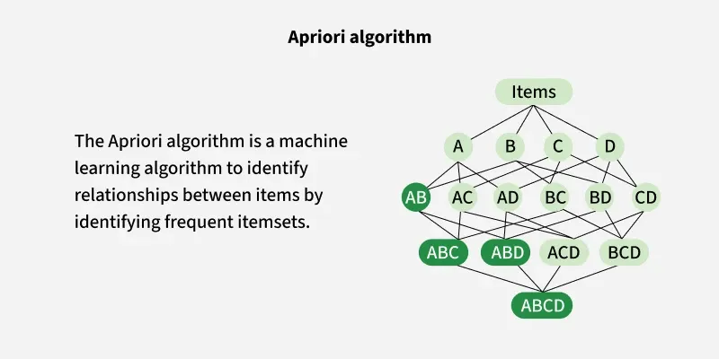
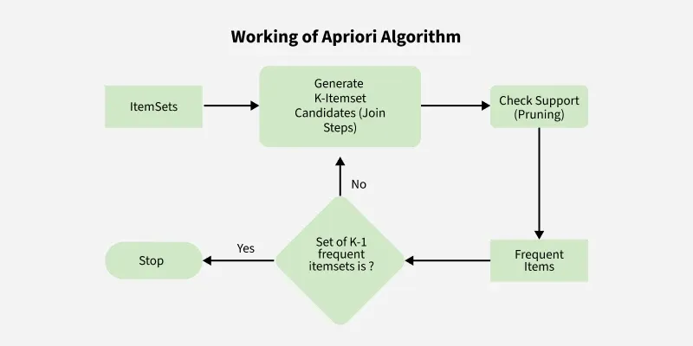

How the Apriori Algorithm Works?
The Apriori Algorithm operates through a systematic process that involves several key steps:

1. Identifying Frequent Itemsets
- The Apriori algorithm starts by looking through all the data to count how many times each single item appears. These single items are called 1-itemsets.
- Next it uses a rule called minimum support this is a number that tells us how often an item or group of items needs to appear to be important. If an item appears often enough meaning its count is above this minimum support it is called a frequent itemset.

2. Creating Possible item group
- After finding the single items that appear often enough (frequent 1-item groups) the algorithm combines them to create pairs of items (2-item groups). Then it checks which pairs are frequent by seeing if they appear enough times in the data.
- This process keeps going step by step making groups of 3 items, then 4 items and so on. The algorithm stops when it can’t find any bigger groups that happen often enough.

3. Removing Infrequent Item groups
- The Apriori algorithm uses a helpful rule to save time. This rule says: if a group of items does not appear often enough then any larger group that incl2 udes these items will also not appear often.
- Because of this, the algorithm does not check those larger groups. This way it avoids wasting time looking at groups that won’t be important make the whole process faster.

4. Generating Association Rules
- The algorithm makes rules to show how items are related.
- It checks these rules using support, confidence and lift to find the strongest ones.

Key Metrics of Apriori Algorithm
- Support: This metric measures how frequently an item appears in the dataset relative to the total number of transactions. A higher support indicates a more significant presence of the itemset in the dataset. Support tells us how often a particular item or combination of items appears in all the transactions ("Bread is bought in 20% of all transactions.")
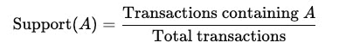
- Confidence: Confidence assesses the likelihood that an item Y is purchased when item X is purchased. It provides insight into the strength of the association between two items. Confidence tells us how often items go together. ("If bread is bought, butter is bought 75% of the time.")
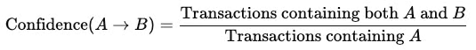
- Lift: Lift evaluates how much more likely two items are to be purchased together compared to being purchased independently. A lift greater than 1 suggests a strong positive association. Lift shows how strong the connection is between items. ("Bread and butter are much more likely to be bought together than by chance.")
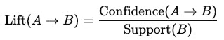

Lets understand the concept of apriori Algorithm with the help of an example. Consider the following dataset, and we will find frequent itemsets and generate association rules for them:
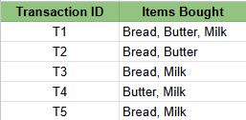
Transactions of a Grocery Shop

Step 1 : Setting the parameters
- Minimum Support Threshold: 50% (item must appear in at least 3/5 transactions). This threshold is formulated from this formula:
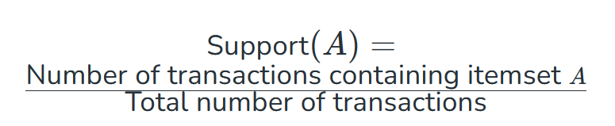
- Minimum Confidence Threshold: 70% ( You can change the value of parameters as per the use case and problem statement ). This threshold is formulated from this formula:

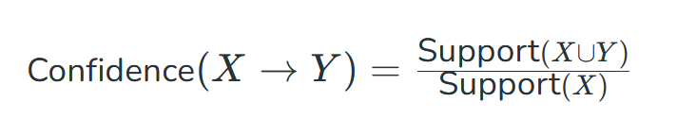

Step 2: Find Frequent 1-Itemsets
Lets count how many transactions include each item in the dataset (calculating the frequency of each item).
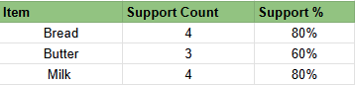
Frequent 1-Itemsets
All items have support% ≥ 50%, so they qualify as frequent 1-itemsets. if any item has support% < 50%, It will be omitted out from the frequent 1- itemsets.

Step 3: Generate Candidate 2-Itemsets
Combine the frequent 1-itemsets into pairs and calculate their support. For this use case we will get 3 item pairs ( bread,butter) , (bread,ilk) and (butter,milk) and will calculate the support similar to step 2
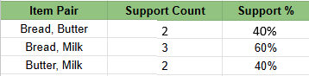
Candidate 2-Itemsets
Frequent 2-itemsets: {Bread, Milk} meet the 50% threshold but {Butter, Milk} and {Bread ,Butter} doesn't meet the threshold, so will be committed out.

Step 4: Generate Candidate 3-Itemsets
Combine the frequent 2-itemsets into groups of 3 and calculate their support. for the triplet we have only got one case i.e {bread,butter,milk} and we will calculate the support.
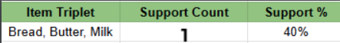
Candidate 3-Itemsets
Since this does not meet the 50% threshold, there are no frequent 3-itemsets.

Step 5: Generate Association Rules
Now we generate rules from the frequent itemsets and calculate confidence.

Rule 1: If Bread → Butter (if customer buys bread, the customer will buy butter also)
- Support of {Bread, Butter} = 2.
- Support of {Bread} = 4.
- Confidence = 2/4 = 50% (Failed threshold).

Rule 2: If Butter → Bread (if customer buys butter, the customer will buy bread also)
- Support of {Bread, Butter} = 2.
- Support of {Butter} = 3.
- Confidence = 2/3 = 66.667% (Failed threshold).

Rule 3: If Bread → Milk (if customer buys bread, the customer will buy milk also)
- Support of {Bread, Milk} = 3.
- Support of {Bread} = 4.
- Confidence = 3/4 = 75% (Passes threshold).

Clustering in Machine Learning

In real world, not every data we work upon has a target variable. Have you ever wondered how Netflix groups similar movies together or how Amazon organizes its vast product catalog? These are real-world applications of clustering. This kind of data cannot be analyzed using supervised learning algorithms.
When the goal is to group similar data points in a dataset, then we use cluster analysis. In this guide, we'll learn understand concept of clustering, its applications, and some popular clustering algorithms.

What is Clustering?
The task of grouping data points based on their similarity with each other is called Clustering or Cluster Analysis. This method is defined under the branch of unsupervised learning, which aims at gaining insights from unlabelled data points.
Think of it as you have a dataset of customers shopping habits. Clustering can help you group customers with similar purchasing behaviors, which can then be used for targeted marketing, product recommendations, or customer segmentation
For Example, In the graph given below, we can clearly see that there are 3 circular clusters forming on the basis of distance.
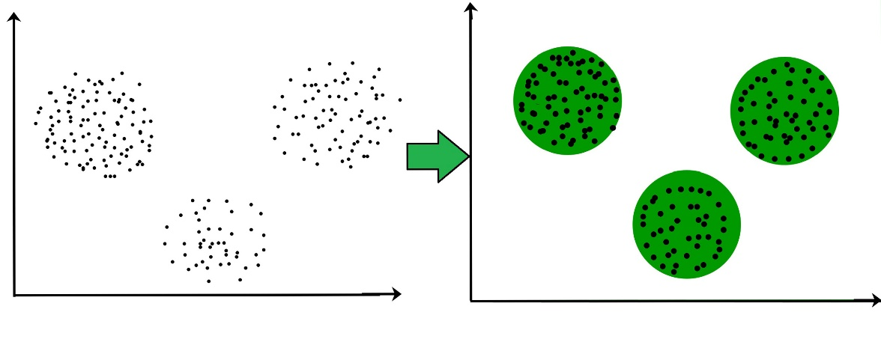
Now it is not necessary that the clusters formed must be circular in shape. The shape of clusters can be arbitrary. There are many algorithms that work well with detecting arbitrary shaped clusters.
For example, In the below given graph we can see that the clusters formed are not circular in shape.
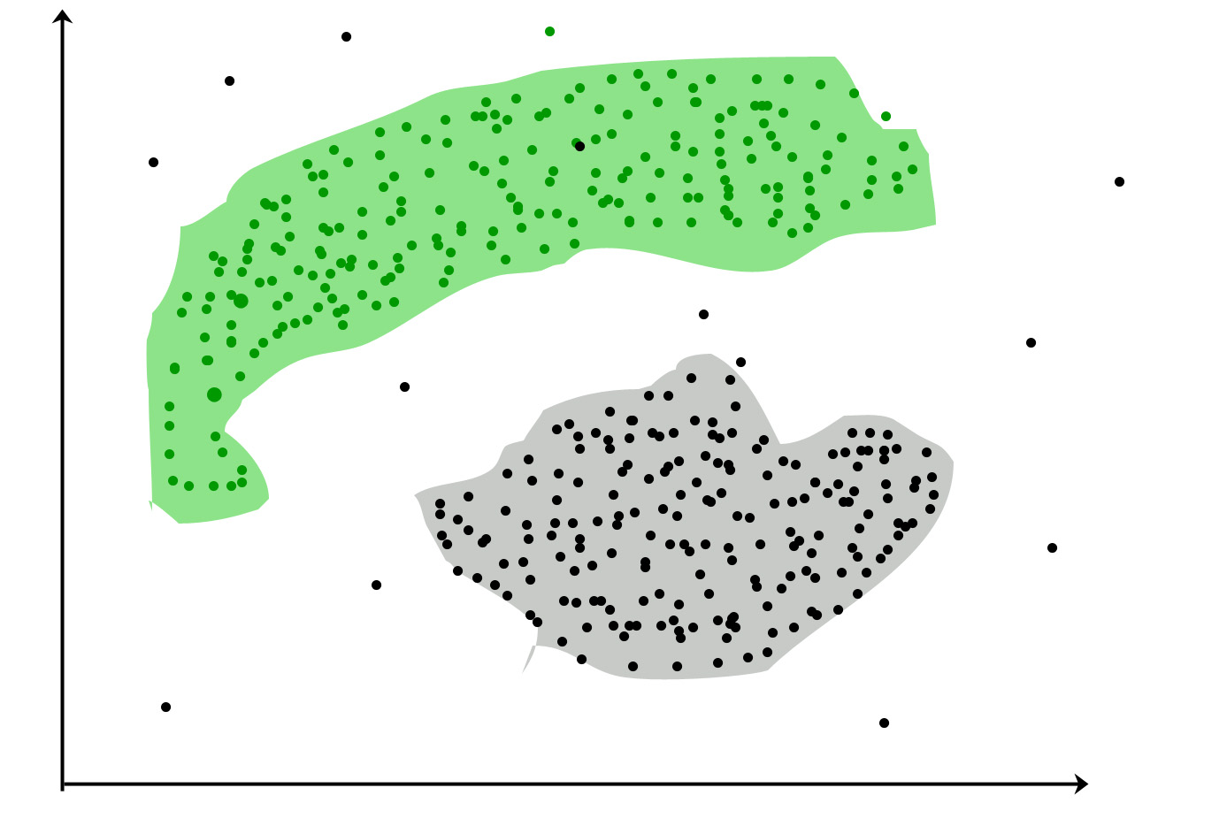

Types of Clustering
Broadly speaking, there are 2 types of clustering that can be performed to group similar data points:
- Hard Clustering: In this type of clustering, each data point belongs to a cluster completely or not. For example, Let's say there are 4 data point and we have to cluster them into 2 clusters. So each data point will either belong to cluster 1 or cluster 2.
Data Points | Clusters
A | C1
B | C2
C | C2
D | C1
- Soft Clustering: In this type of clustering, instead of assigning each data point into a separate cluster, a probability or likelihood of that point being that cluster is evaluated. For example, Let's say there are 4 data point and we have to cluster them into 2 clusters. So we will be evaluating a probability of a data point belonging to both clusters. This probability is calculated for all data points.
Data Points | Probability of C1 | Probability of C2
A | 0.91 | 0.09
B | 0.3 | 0.7
C | 0.17 | 0.83
D | 1 | 0

Uses of Clustering
Now before we begin with types of clustering algorithms, we will go through the use cases of Clustering algorithms. Clustering algorithms are majorly used for:
- Market Segmentation: Businesses use clustering to group their customers and use targeted advertisements to attract more audience.
- Market Basket Analysis: Shop owners analyze their sales and figure out which items are majorly bought together by the customers. For example, In USA, according to a study diapers and beers were usually bought together by fathers.
- Social Network Analysis: Social media sites use your data to understand your browsing behavior and provide you with targeted friend recommendations or content recommendations.
- Medical Imaging: Doctors use Clustering to find out diseased areas in diagnostic images like X-rays.
- Anomaly Detection: To find outliers in a stream of real-time dataset or forecasting fraudulent transactions we can use clustering to identify them.
- Simplify working with large datasets: Each cluster is given a cluster ID after clustering is complete. Now, you may reduce a feature set's whole feature set into its cluster ID. Clustering is effective when it can represent a complicated case with a straightforward cluster ID. Using the same principle, clustering data can make complex datasets simpler.
There are many more use cases for clustering but there are some of the major and common use cases of clustering. Moving forward we will be discussing Clustering Algorithms that will help you perform the above tasks.

K means Clustering – Introduction

K-Means Clustering is an Unsupervised Machine Learning algorithm that groups an unlabeled dataset into different clusters. It is used to organize data into groups based on their similarity.

How k-means clustering works?
We are given a data set of items with certain features and values for these features like a vector. The task is to categorize those items into groups. To achieve this we will use the K-means algorithm. 'K' in the name of the algorithm represents the number of groups/clusters we want to classify our items into.
The algorithm will categorize the items into k groups or clusters of similarity. To calculate that similarity, we will use the Euclidean distance as a measurement. The algorithm works as follows:
- First, we randomly initialize k points called means or cluster centroids.
- We categorize each item to its closest mean, and we update the mean's coordinates, which are the averages of the items categorized in that cluster so far.
- We repeat the process for a given number of iterations, and at the end, we have our clusters.
The "points" mentioned above are called means because they are the mean values of the items categorized in them. To initialize these means, we have a lot of options. An intuitive method is to initialize the means at random items in the data set. Another method is to initialize the means to random values between the boundaries of the data set. For example, for a feature x, the items have values in [0,3] we will initialize the means with values for x at [0,3].
Example: Apply K(=2)-Means algorithm over the data (185, 72), (170, 56), (168, 60), (179,68), (182,72), (188,77) up to two iterations and show the clusters. Initially, choose the first two objects as initial centroids.
Solution:
Given, number of clusters to be created (K) = 2 say c1 and c2, number of iterations = 2 and
The given data points can be represented in tabular form as:
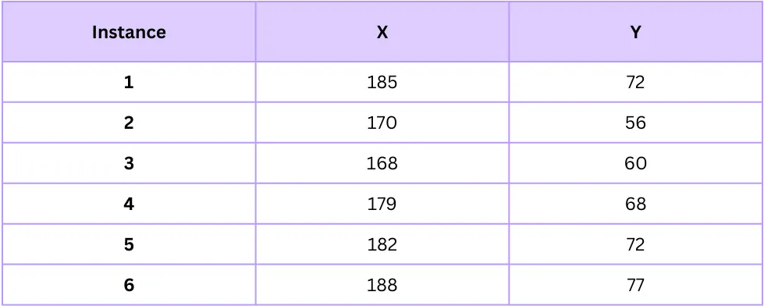

also, first two objects as initial centroids:
Centroid for first cluster c1 = (185, 72)
Centroid for second cluster c2 = (170, 56)
Iteration 1: Now calculating similarity by using Euclidean distance measure as:
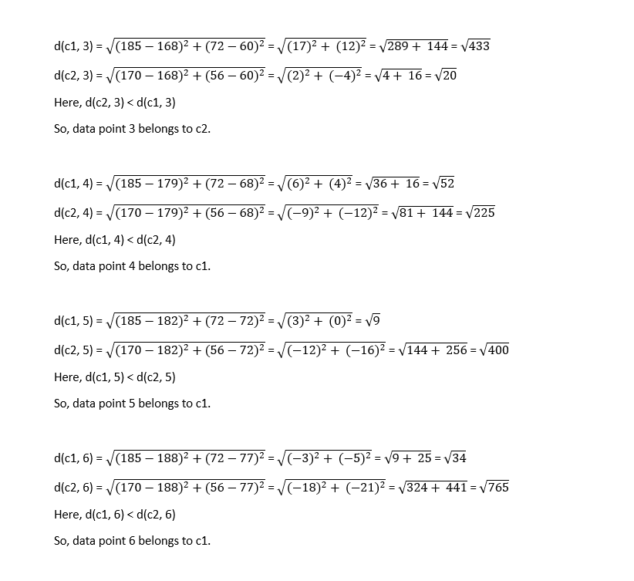
Euclidean distance calculation
Representing above information in tabular form:
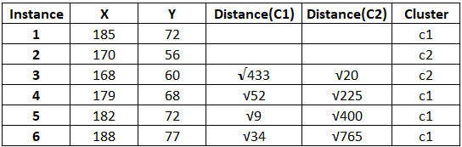
Distance of each data points from cluster centroids
The resulting cluster after first iteration is:
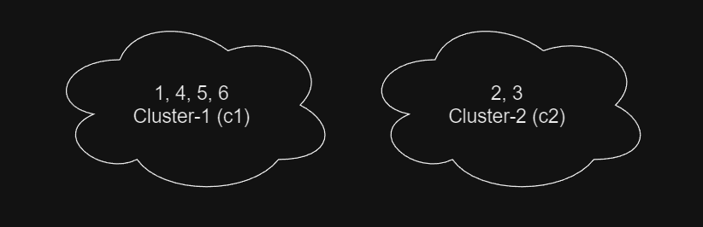
Data points cluster
Iteration 2: Now calculating centroid for each cluster:
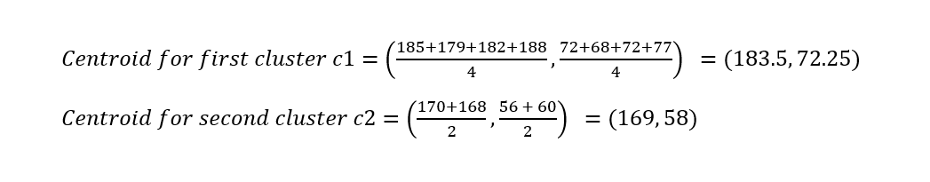
Calculating centroid as mean of data points
Now, again calculating similarity:
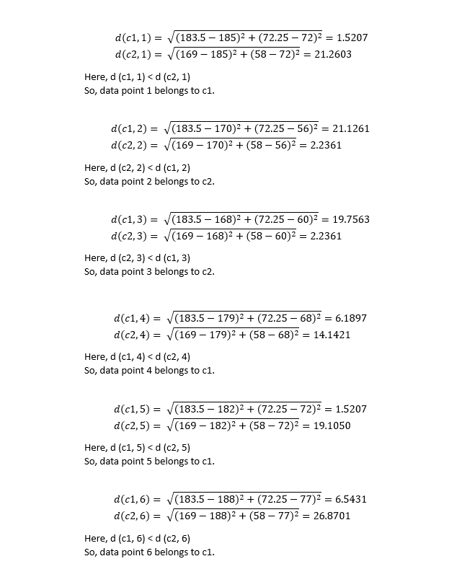
Distance calculation between data points and centroids
Representing above information in tabular form.
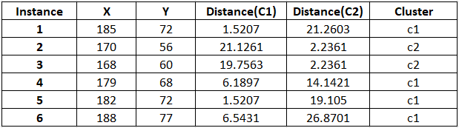
Distance of each data points from cluster centroids
The resulting cluster after second iteration is:
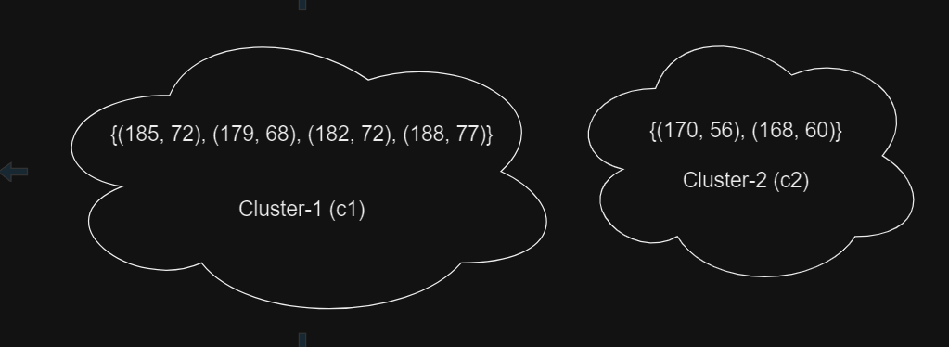
Data points cluster
As we have already completed two iterations as asked by our question, the numerical ends here.
Since the clustering doesn’t change after the second iteration, terminate the iteration even if the question doesn’t say so.

Feature | X | y
Example 1 | 4 | 11
Example 2 | 8 | 4
Example 3 | 13 | 5
Example 4 | 7 | 14

Step 1:Dataset
No. of feature, n=2
No. of samples, N=4
Step 2: Computation of Mean of variables
x̄= (4+8+13+7)/4=8
ȳ= (11+4+5+14)/4=8.5

Step 3: Computation of Covariance matrix

